**PROJECT REPORT**

**Project Name:**

ID card Generator

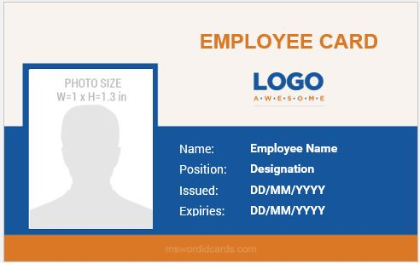

**Group Members:**

* Mohammad Basil Ali Khan (20K - 0477 )
* Abdul Ahad Shaikh (20K -0319)
* Syed Jodat Ali Naqvi (20K -0155)

**Objective:**

The main objective of this project is to implement the concept of object oriented programming language and its feature. For this we have made a system that generate ID cards of students, teachers and admins.

**Programming Language, Concepts and Feature used:**

The programming language we used is C++ to use the concept of object oriented programming language.

The Concepts and Features we used in our project are:

1. Inheritance
2. Single Inheritance
3. Multiple Inheritance
4. Polymorphism
5. Runtime Polymorphism
6. Pure Virtual Function
7. File Handling
8. Static Concept
9. GUI

**Class Diagram:**

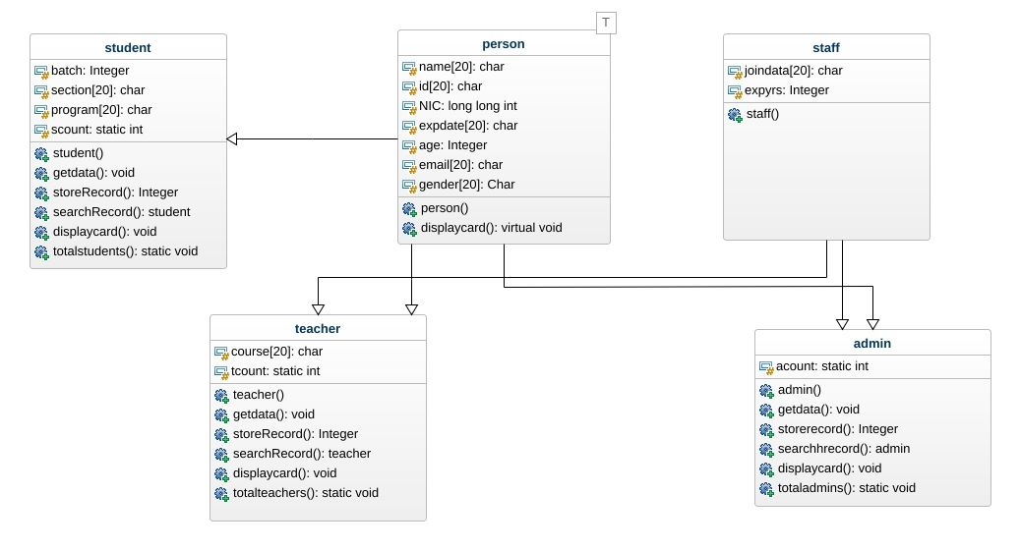

**Module in Systems:**

* Person
* Staff
* Students
* Teachers
* Admins

**Modules Description:**

* **Person:**

It’s our first base class having all necessary attributes of other classes.

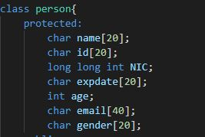

* **Staff:**

It’s second base class for employees having same necessary attributes.

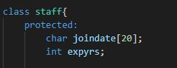

* **Students:**

Student is derived class and derived from student using single inheritance.

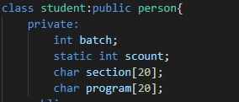

* **Teachers:**

Teacher is also derived class and is derived from person and staff using multiple inheritance.

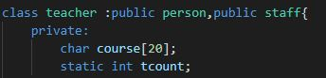

* **Admins:**

Admin is also derived class and is derived from person and staff using multiple inheritance.



**System Description:**

* **Login:**

The college/university administration have given password to only one person handling this system and login with the correct password. Only he can login and store data and generate cards for students, teacher and admin.

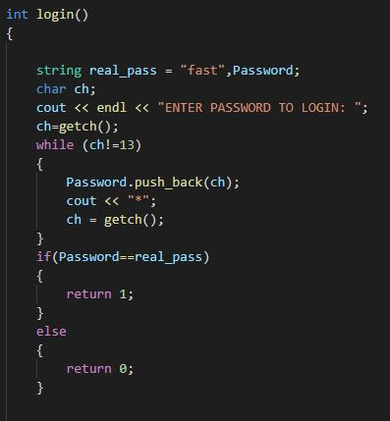 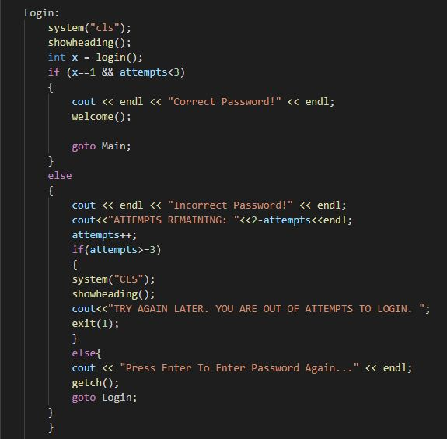

* **Adding New Record:**

The person handling the system will choose appropriate option to add record of whether the record of student, teacher or admin. For this we have used the concept of file handling.

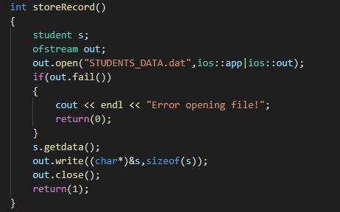 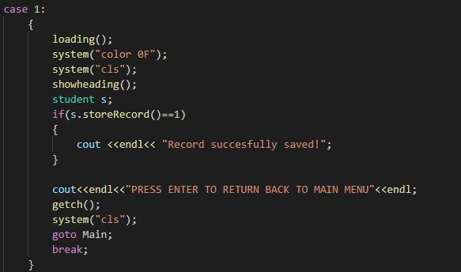

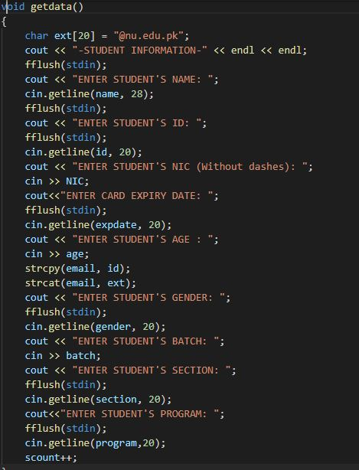

* **Searching Record:**

The person handling the system will choose appropriate option to search record depending on entered id whether the record of student, teacher or admin. For this we have used the concept of file handling.

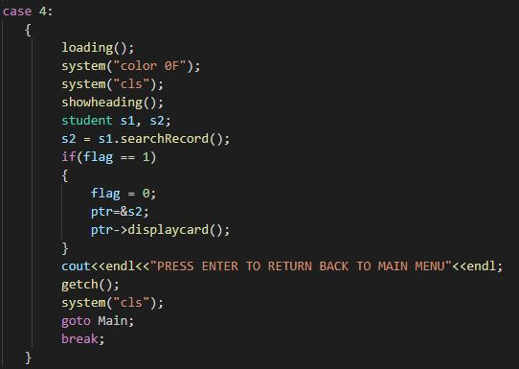 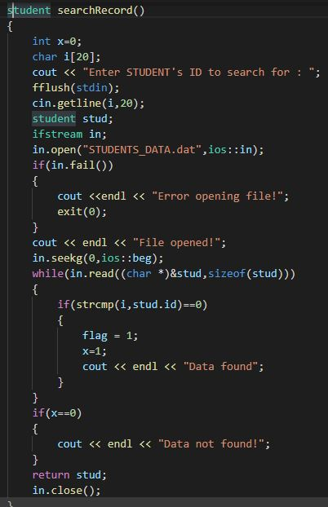

* **Generating And Displaying Card:**

The person handling the system will choose appropriate option to display record depending on entered id whether the record of student, teacher or admin exist. For this we have used the concept of file handling.

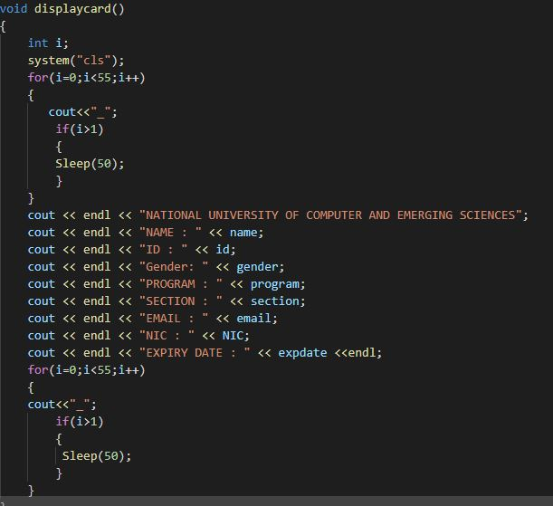 

* **Some Other Feature Of Code;**

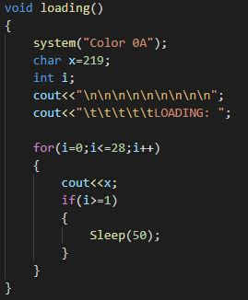

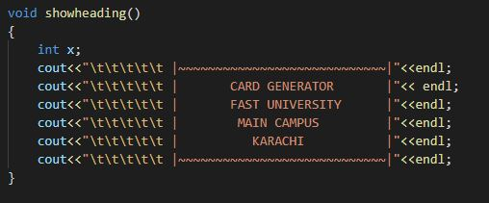

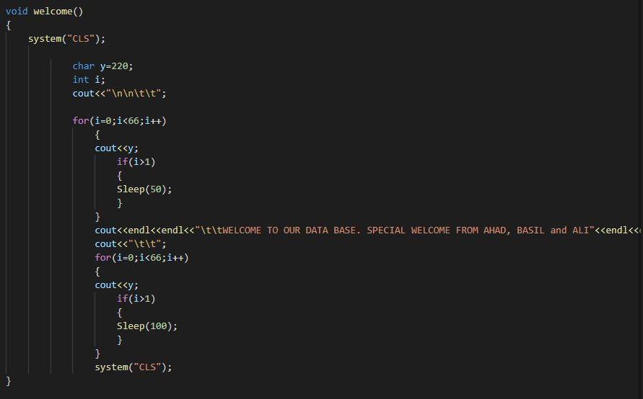

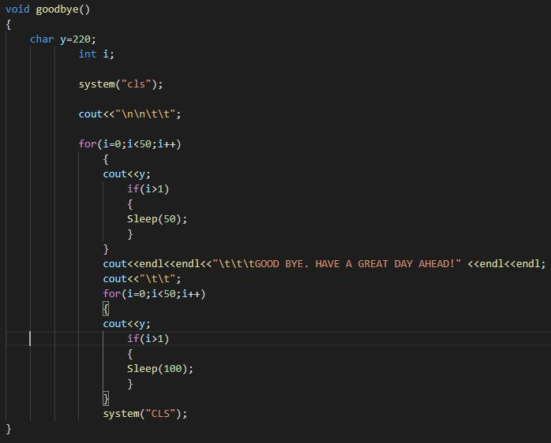

**Conclusion:**